**View Insight:**

**1)**

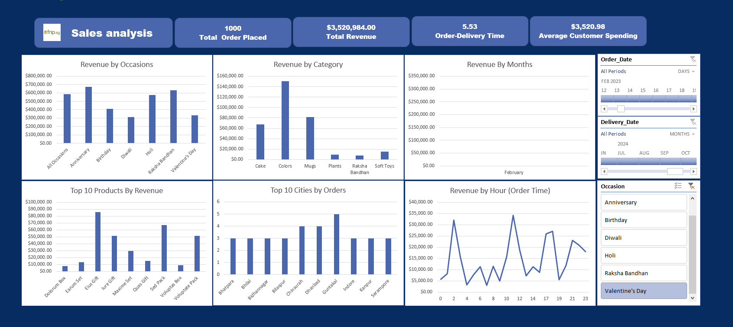

Sales are concentrated **only in February**, which confirms that Valentine’s Day orders are highly seasonal.

**2)**

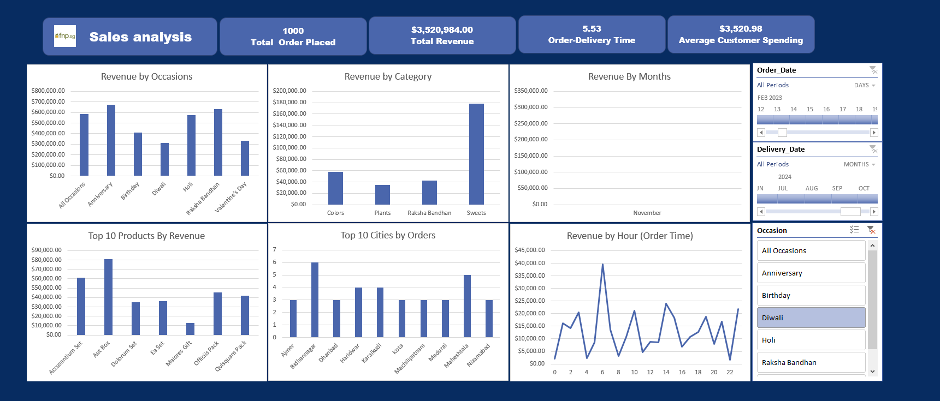

Sales are concentrated **only in November**, which confirms that Diwali Day orders are highly seasonal in 2023.

**3)** 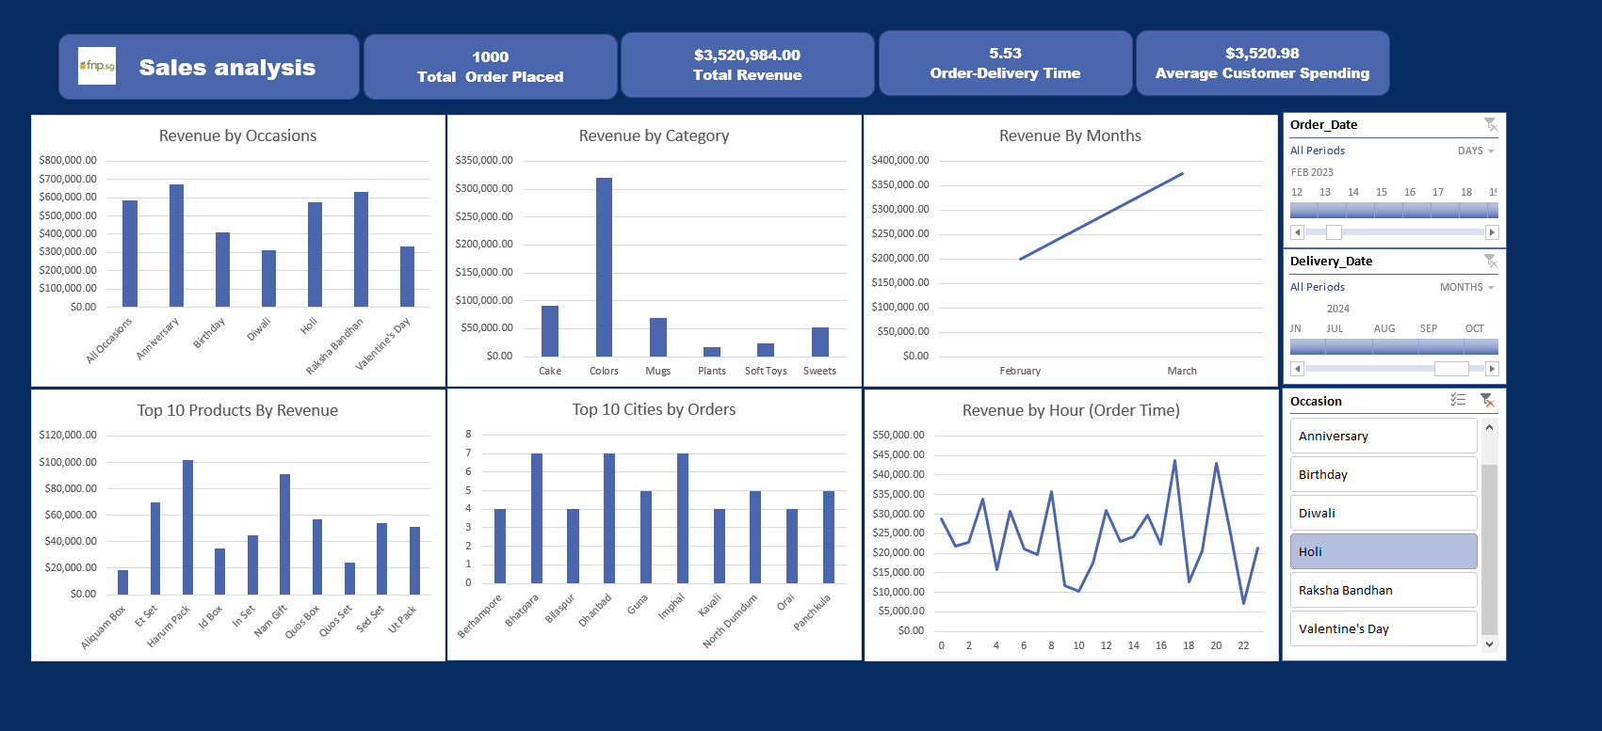

During Holi 2023, the sales occurred mainly in February and March, with Colors being the most purchased category in these months.

**4)** Highest revenue is generated on **Anniversaries** and **Raksha Bandhan**.

**5)** **Valentine’s Day** and **Diwali** show relatively lower revenue compared to other occasions.

**IMPORTANT NOTE:**

The **Revenue by Occasion** chart remains static and is **not impacted by slicer filtering**. All other charts respond dynamically, enabling deeper exploration of sales performance across dates and customer behavior.